**RESUME**

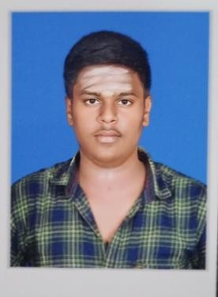

# VIGNESH M

Mobileno: 8072503704

Emailid:[vigneshvicky13052003@gmail.com](mailto:vigneshvicky13052003@gmail.com)

**CAREEROBJECTIVE:**

To secure a position, where I can efficiently contribute my skills and abilities to thegrowth of the organization and build my professional career.

|  |  |  |  |  |  |  |
| --- | --- | --- | --- | --- | --- | --- |
|  | **ACADEMICQUALIFICATION:** | | | | |  |
| **Degree/ Course** | | **Institution** | **University/**  **Board** | **YearofPassing** | **%orcgpaof Marks** | |
| B.E(Computer Science and Engineering)  3rdYear | | SethuInstituteof Technology | Autonomous | 2024 | 8.1(CGPAupto 6 semester) | |
| HSC | | Velammal Matric HigherSecSchool | StateBoard | 2020 | 65.6% | |
| SSLC | | Velammal Matric HigherSecSchool | StateBoard | 2018 | 78.8% | |

**TECHNICALSKILLS:**

# C, HTML,CSS

* IOT

**AREAOFINTEREST:**

* Web design
* MobileApp development

**MINIPROJECT:**

* Completedamini projecton“Temperatureadaptablesuit”

**PERSONALDETAILS:**

|  |  |
| --- | --- |
| **Father’s Name :** | MuthukrishnanP |
| **Mother’sName :** | SudhaRani M |
| **Dateof Birth :** | 13.05.2003 |
| **LanguageKnown :** | English,Tamil |
| **Address :** | 4/100SambakulamStreet,  Vayalcheri,ThiruppuvanamTaluk, Sivagangai District |
| **Pincode :** | 630611 |

**DECLARATION:**

Iherebydeclaretheabovementioneddetailsaretruetothebestofmy knowledge and belief.

DATE: YoursFaithfully

PLACE:Vayalcheri M.Vignesh